Terraform Task -03
1. Execute all the templates shown in the video.
Create a new project on windows and go to File → Open Folder → terraform-project

Create main.tf
In the VS Code Explorer:
- Right-click terraform-project
- Select New File
- Name it: main.tf
From inside the project folder:
Run terraform init
Terraform will download the AWS provider and create a .terraform directory.
You should then have:
terraform-project/
├── .terraform/
├── .terraform.lock.hcl
└── main.tf
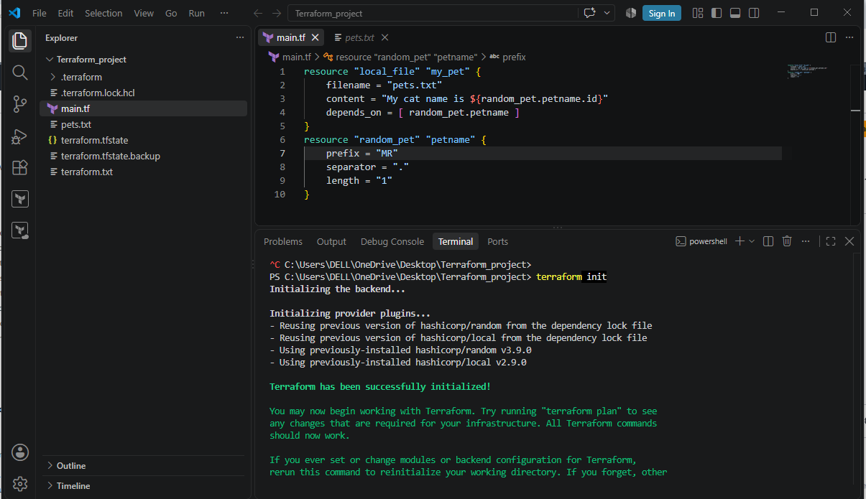

terraform validate, terraform fmt and terraform plan.
Expected:
Success! The configuration is valid.

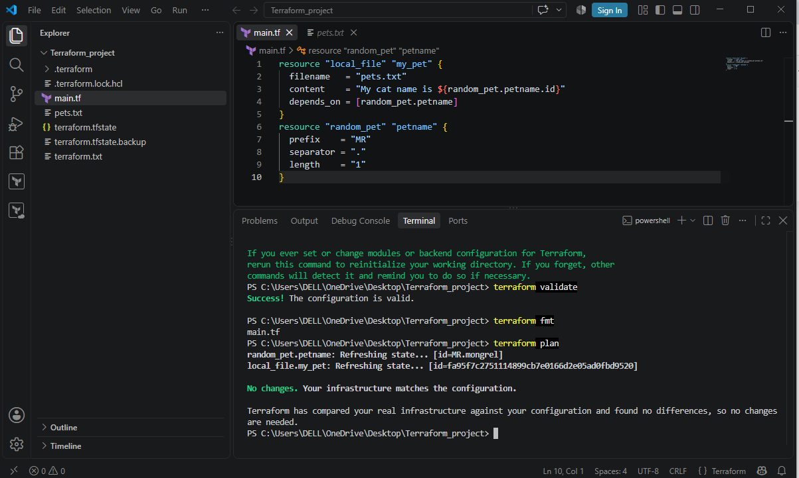
Output file:
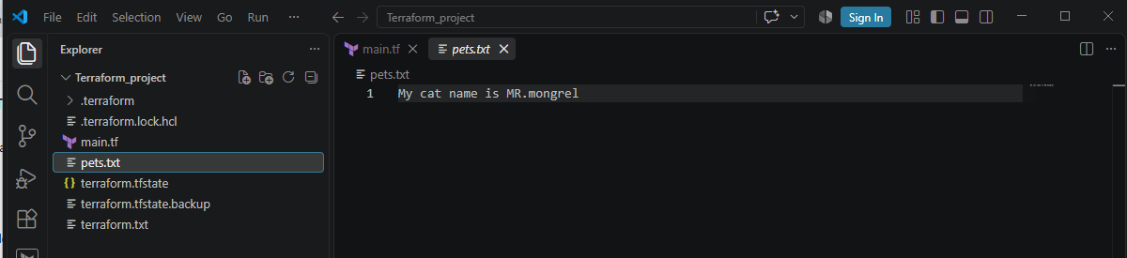

Terraform State File
The Terraform state file is a file Terraform uses to remember the infrastructure it has created and manage it in future operations.
The default state file is: terraform.tfstate
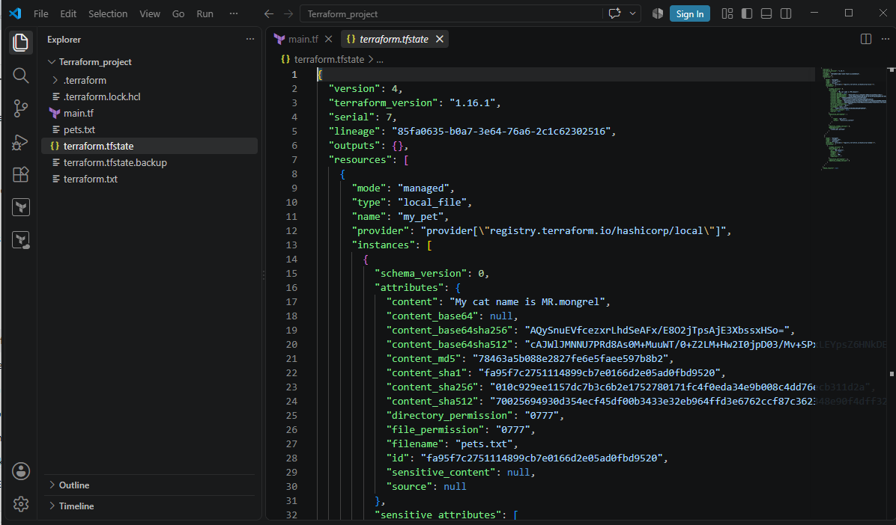
terraform.lock.hcl is a dependency lock file created by Terraform.
Its main purpose is to lock the provider version that your Terraform project uses.
terraform.lock.hcl helps ensure that the project uses the same selected provider version and verified provider package.
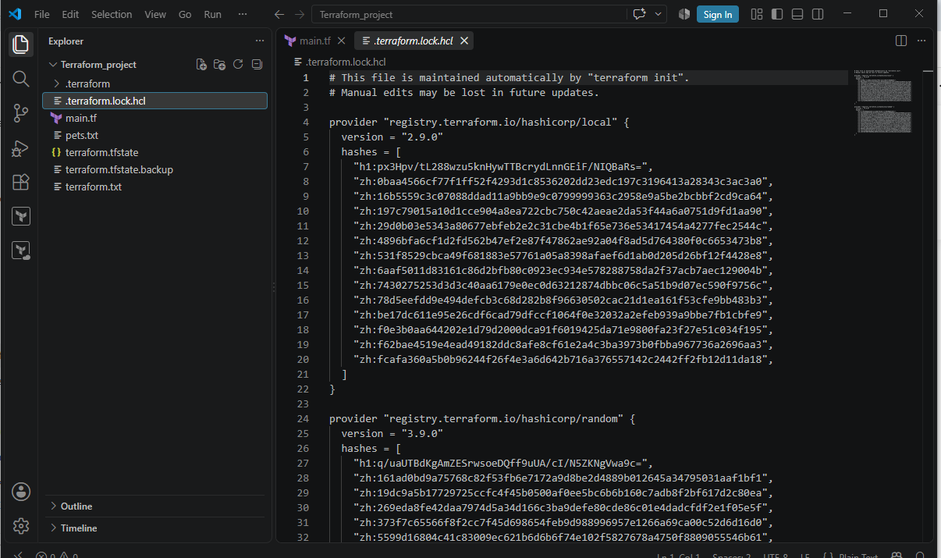
Variable.tf file:
The main purpose of variable.tf is to define input variables so that your Terraform code is reusable, flexible, and easier to change.
Instead of hardcoding values in main.tf, you define variables and use them.
1. By using variable.tf file:
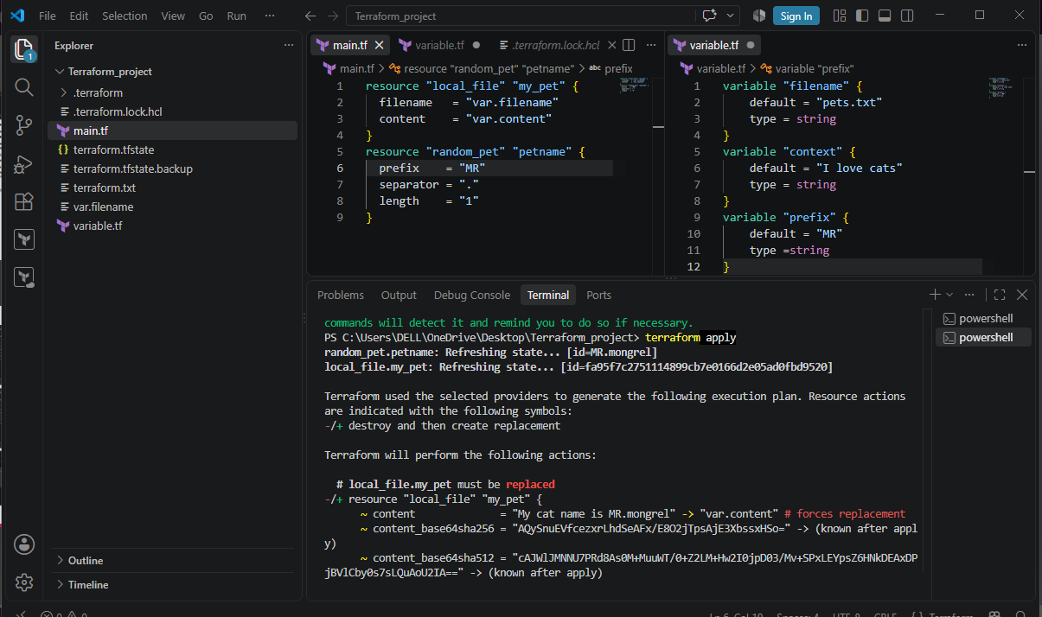
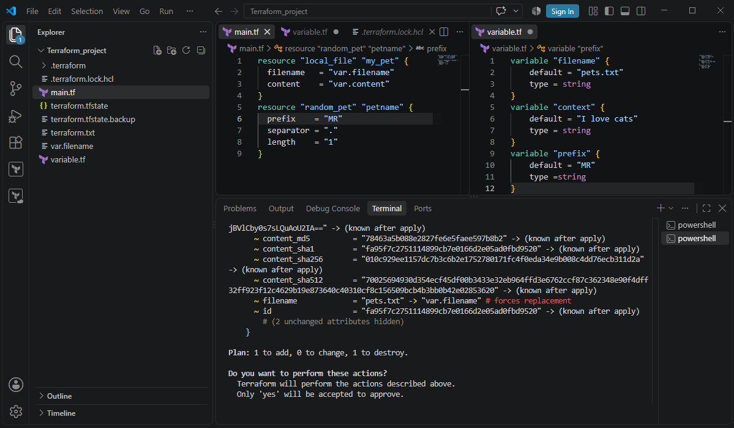

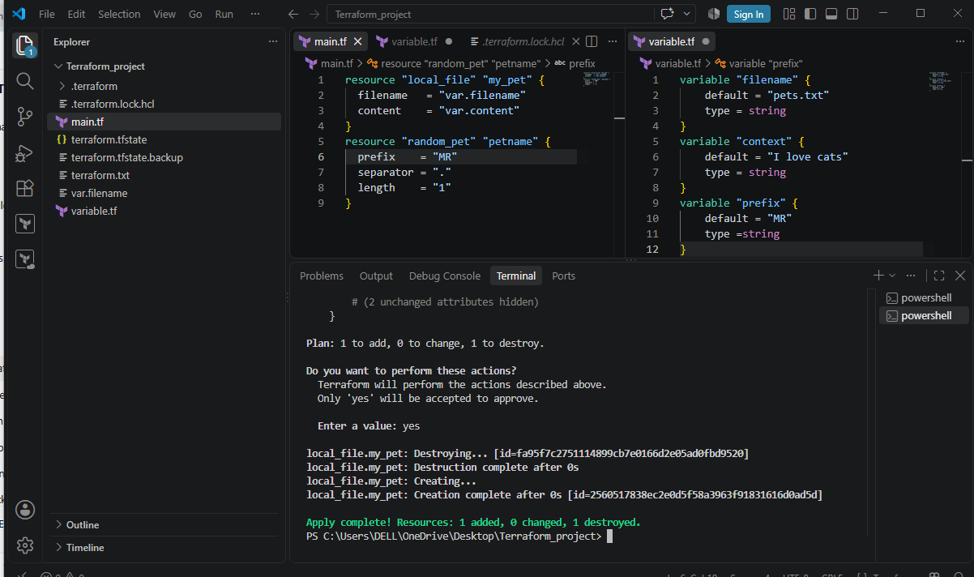
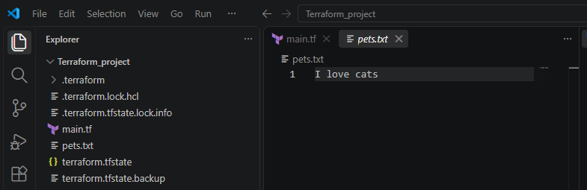
2. By using interactive mode:
If we are declaring empty variables and not passing the default variables then at run time when executing terraform apply it asks to enter the value.
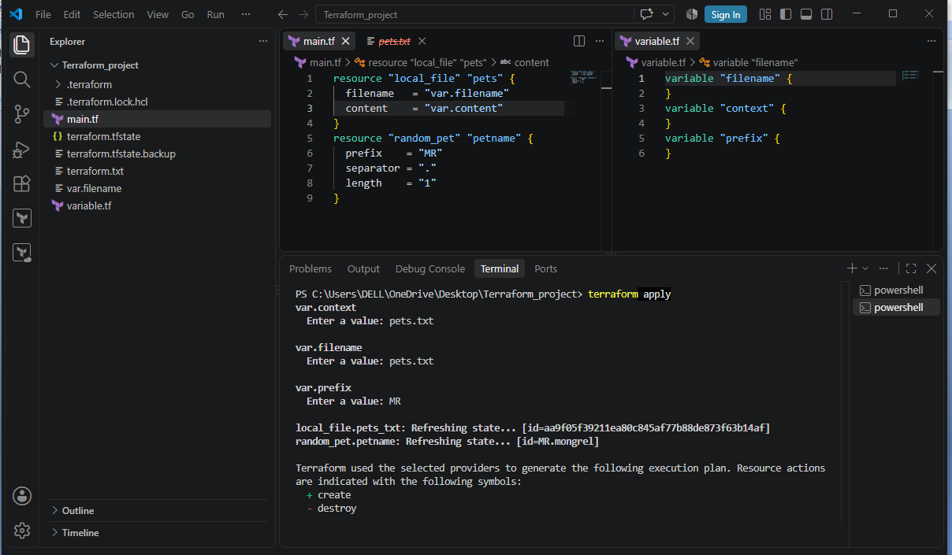
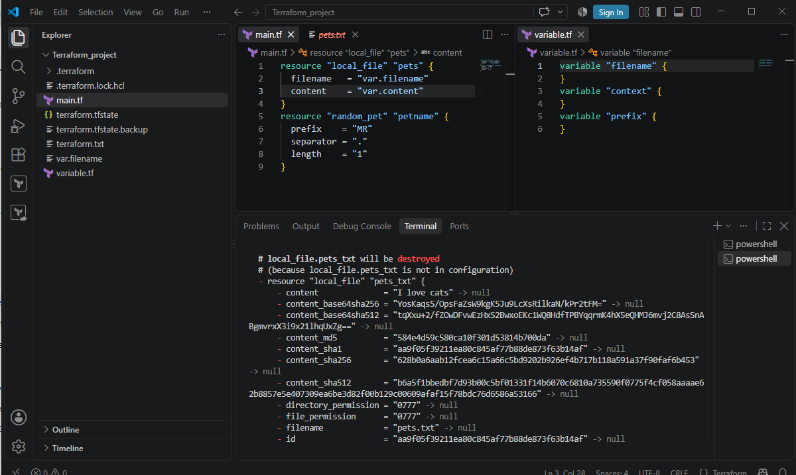

3. Using command line flags:
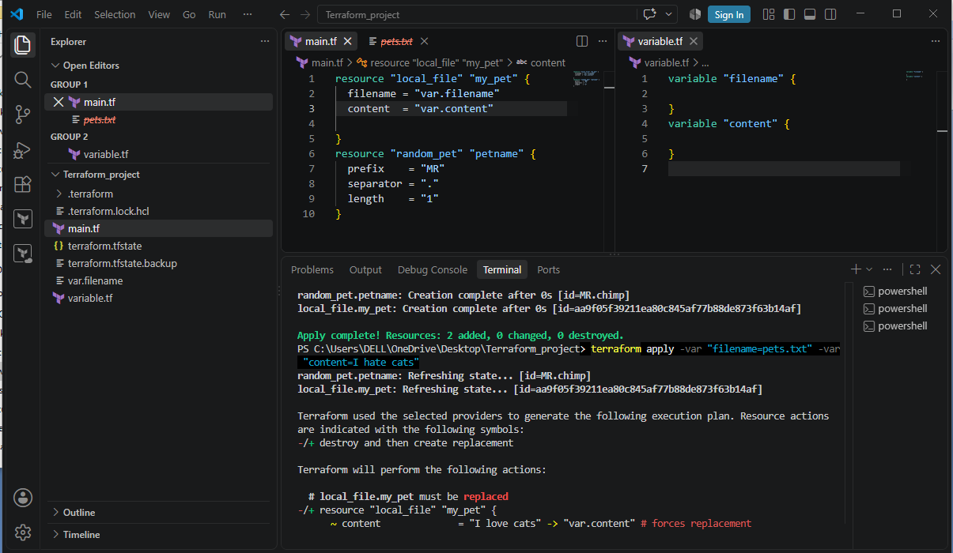
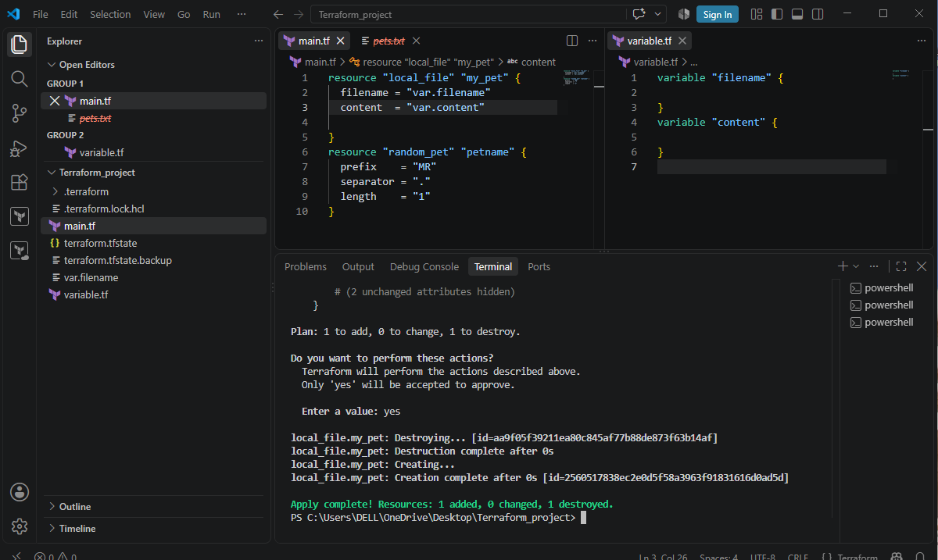
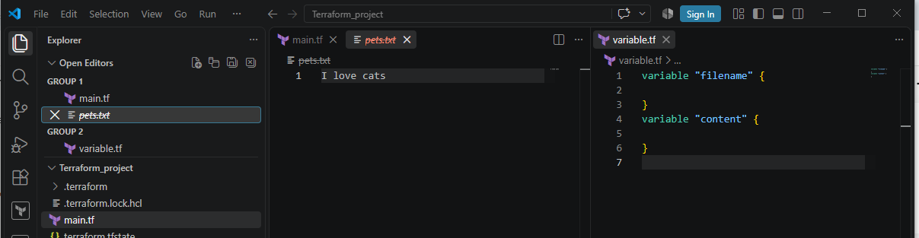

Terraform Lifecycle Rules
Terraform lifecycle rules tell Terraform how to handle a resource when it is created, updated, or destroyed.
There are 3 important lifecycle rules you should know:

1. create_before_destroy
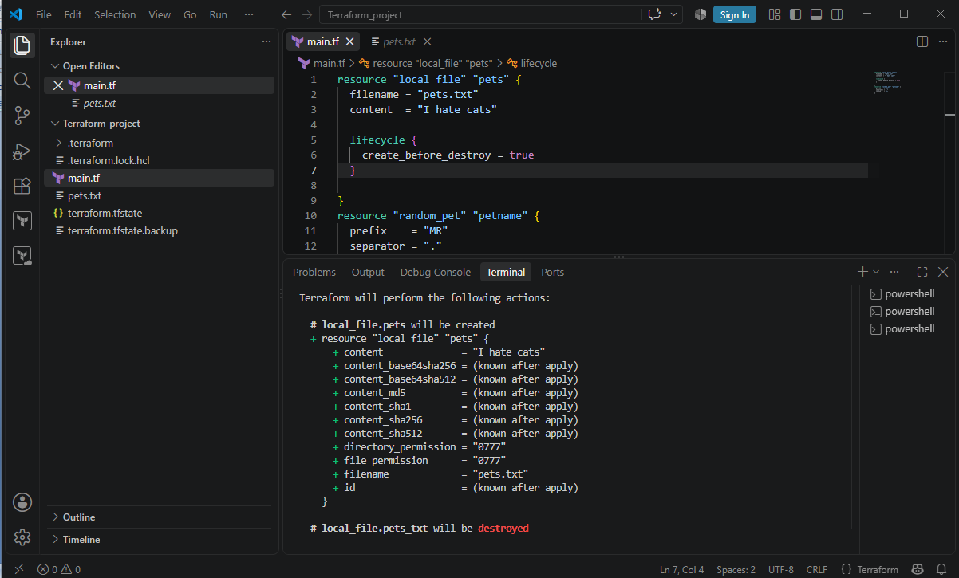
2. prevent_destroy
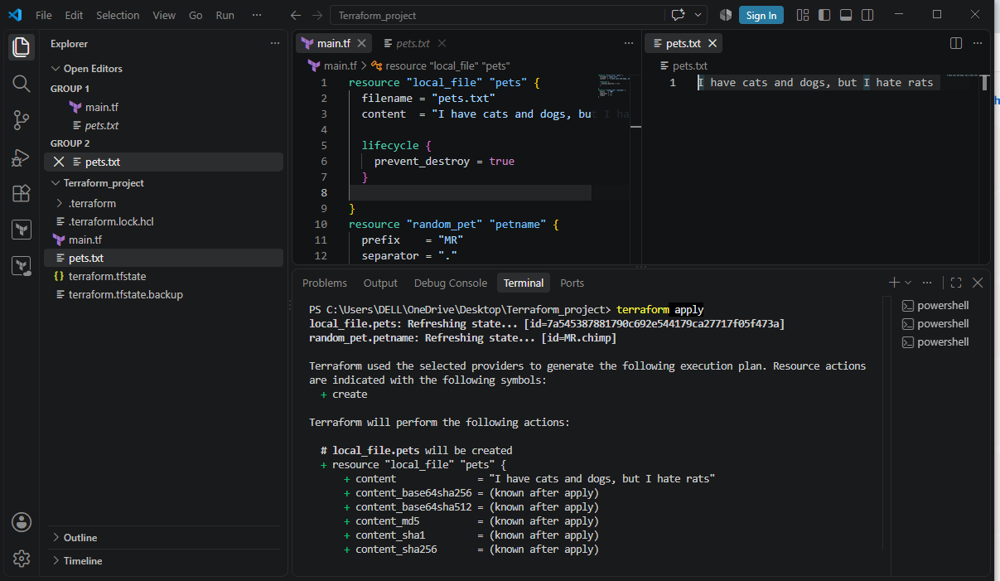

3. Ignore changes
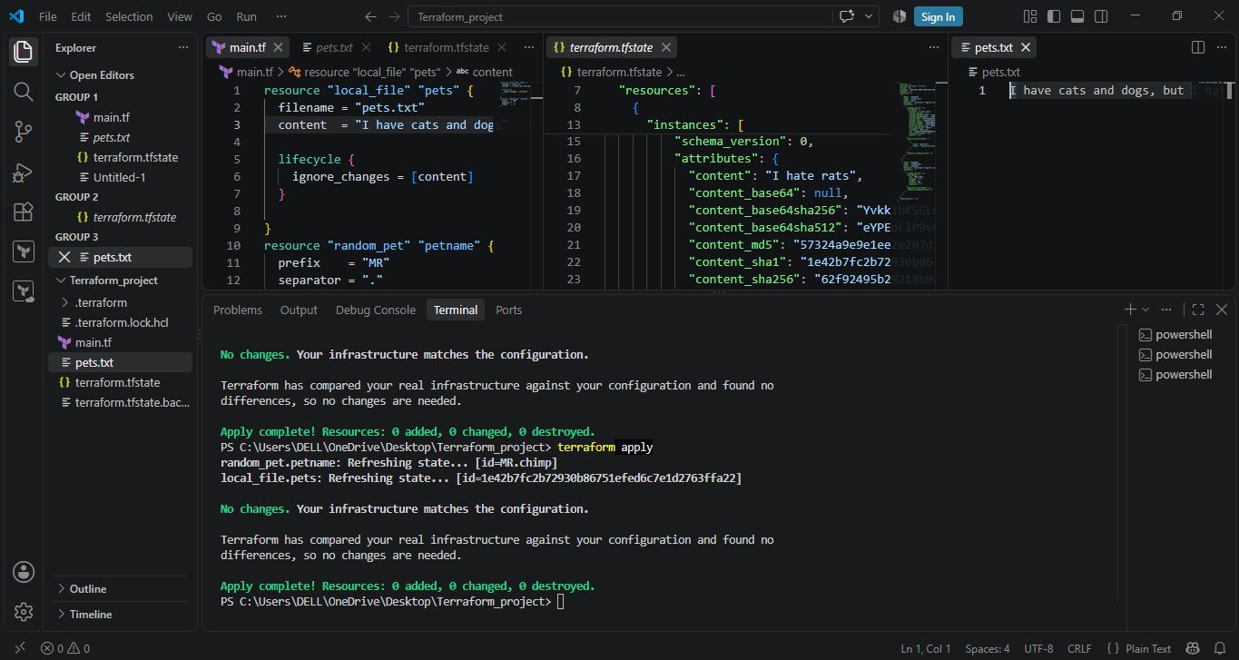
3). Integrate Terraform in Jenkins using the Terraform plugin.
Install Terraform on the Jenkins server/agent
Make sure the terraform command is available.
Step 1:Verify: terraform version
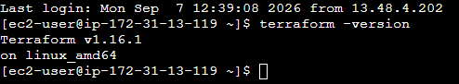

Step 2: Open Jenkins GUI using http://<EC2-PUBLIC-IP>:8080
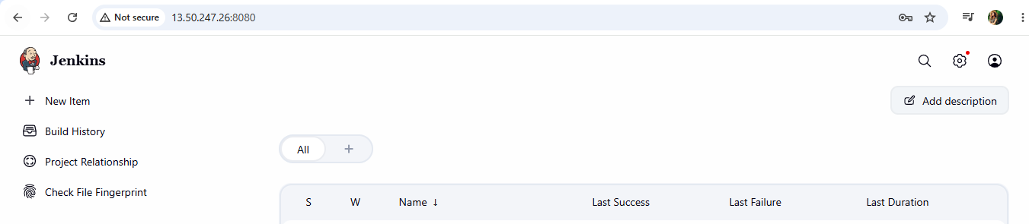

Step 3: Install the Terraform plugin
- Go to Jenkins → Manage Jenkins → Plugins.
- Search for the Terraform plugin and install it.
- Restart Jenkins if required.
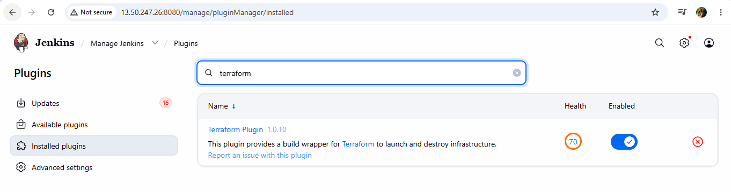
Step 4: Configure Terraform
- Go to Manage Jenkins → Tools.
- Add/configure the Terraform installation.
- Give it a name such as terraform.
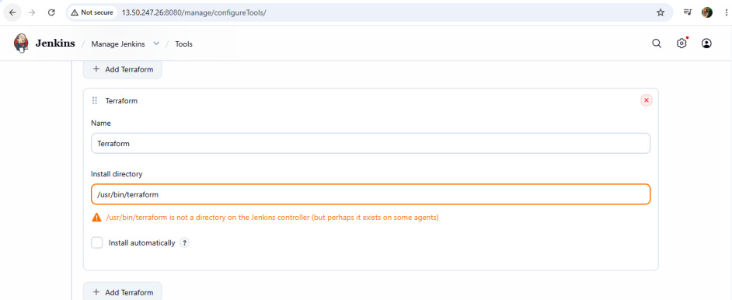

Step 5: Create a Jenkins Pipeline
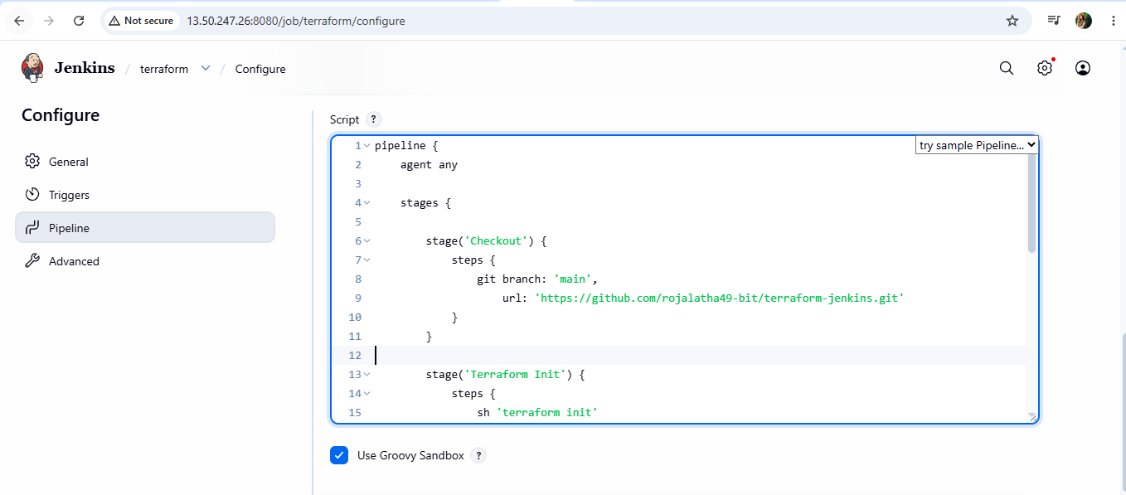
Step 6: Execute the job by clicking ob build now:
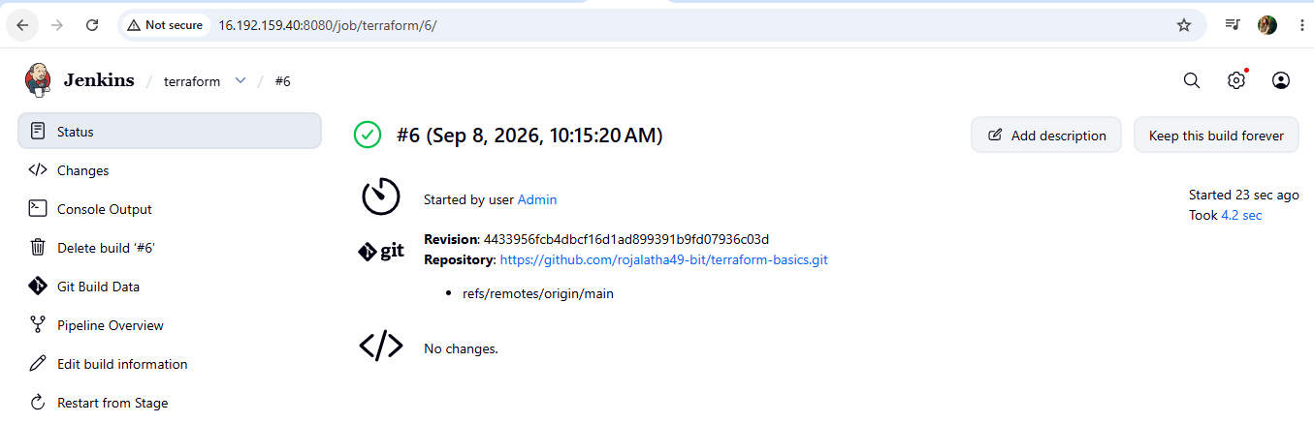

4. Create one Jenkins job using Maven Project for the code below with two stages:
  - Stage 1:Git clone
  - Stage 2:Maven CompilationCode:https://github.com/betawins/java-Working-app.git

Step 1: Prerequisites
On your Jenkins server, make sure Git, Java, and Maven are installed:
git --version
java -version
mvn –version

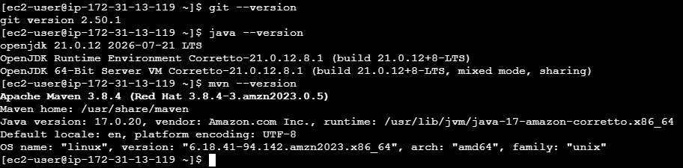
Step 2: Install maven Integration plugin
Go to Jenkins → Manage Jenkins→ Available plugins
Search for Maven integration and install it.
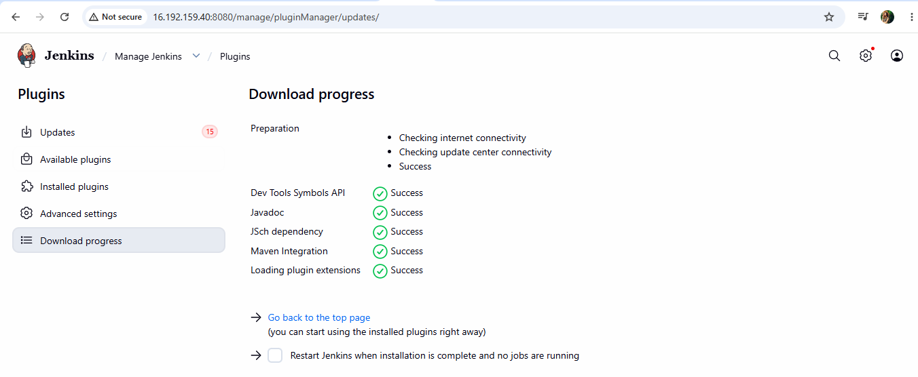

Step 3. Create the Jenkins Maven Project
Go to: Jenkins → New Item
Enter a name, for example: java-maven-build
Select: Maven project
Click OK.
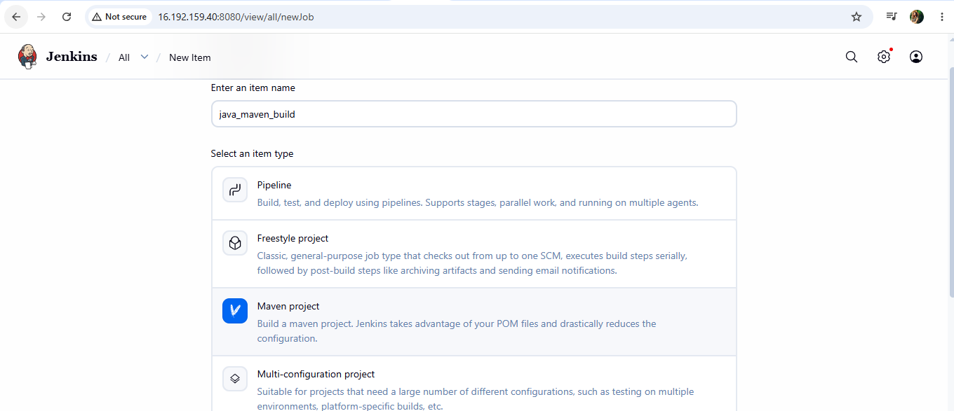

Step 4: Stage 1 — Git Clone
In the Jenkins job configuration, find Source Code Management.
Select:
Git
Repository URL:
https://github.com/betawins/java-Working-app.git
For Branch Specifier, use:
*/main
If the repository's default branch is master, use:
*/master
Jenkins will perform the Git checkout automatically. You don't need to manually write git clone in a Maven Project.
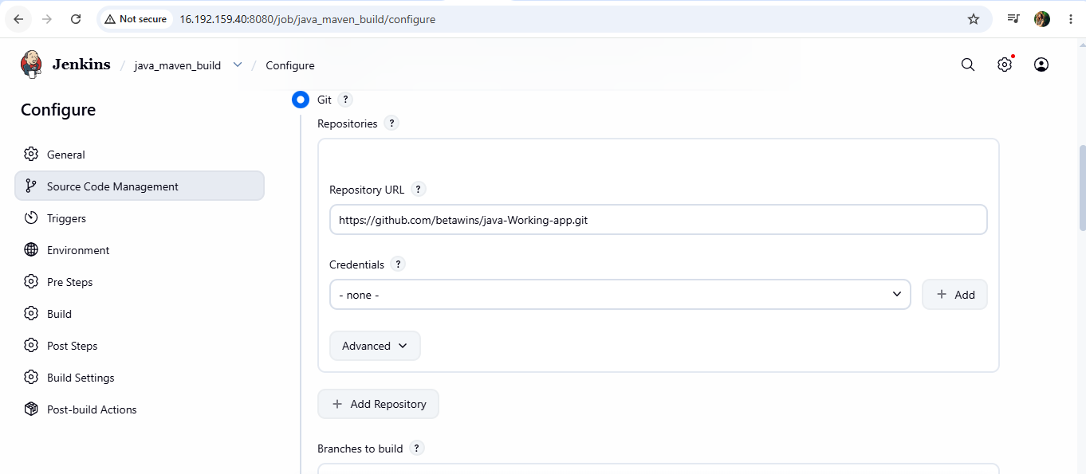
Now execute the job by clicking on build now:
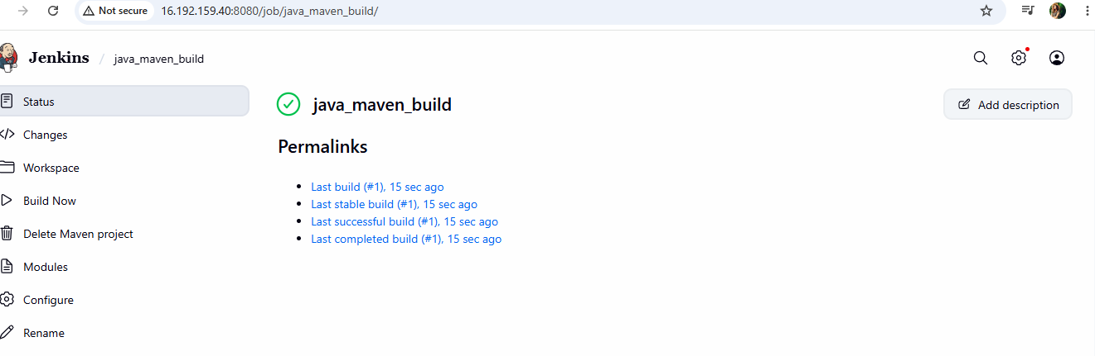
5. Use the same code and create a parameterized job in Jenkins with:
  - Stage 1:Git clone
  - Stage 2:Maven CompilationCode:https://github.com/betawins/java-Working-app.git

Step 1: Create the job
Go to: Jenkins → New Item
Enter: java-maven-parameterized
Select: Freestyle project
Click OK.
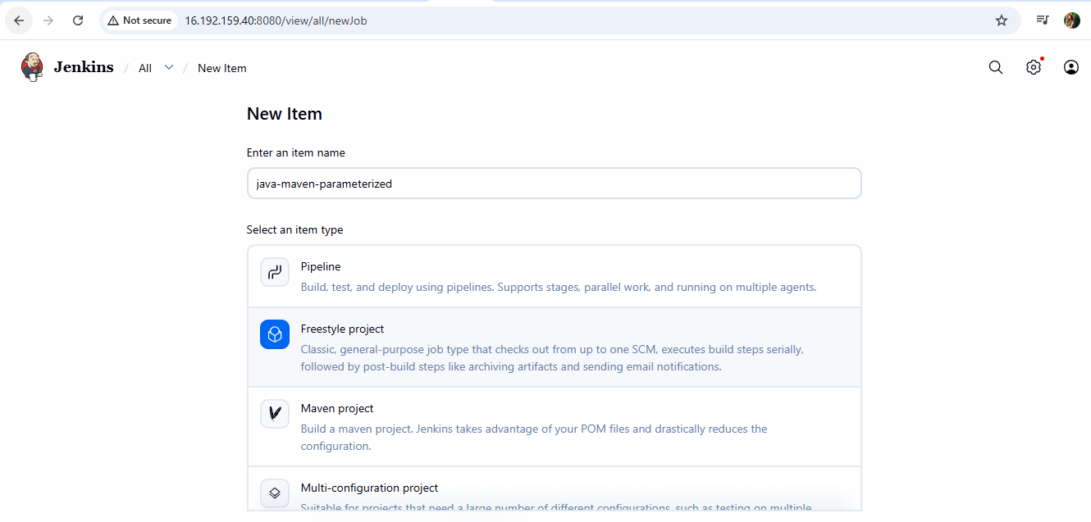

Step 2: Make it parameterized
In the job configuration, check: This project is parameterized
Click Add Parameter → Choice Parameter
Configure:
Name: BUILD_TYPE

Choices:
compile
test
package
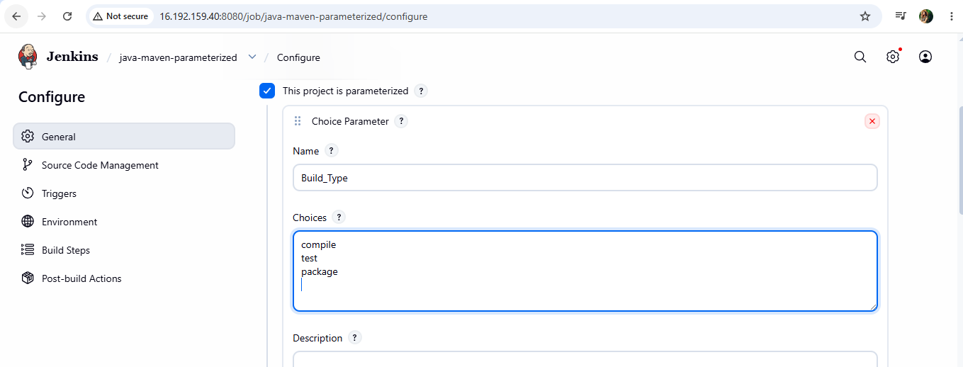

Step 3: Stage 1 — Git Clone
Under Source Code Management: Select Git
Repository URL: https://github.com/betawins/java-Working-app.git
Branch: */main
Jenkins will automatically clone/checkout the repository.
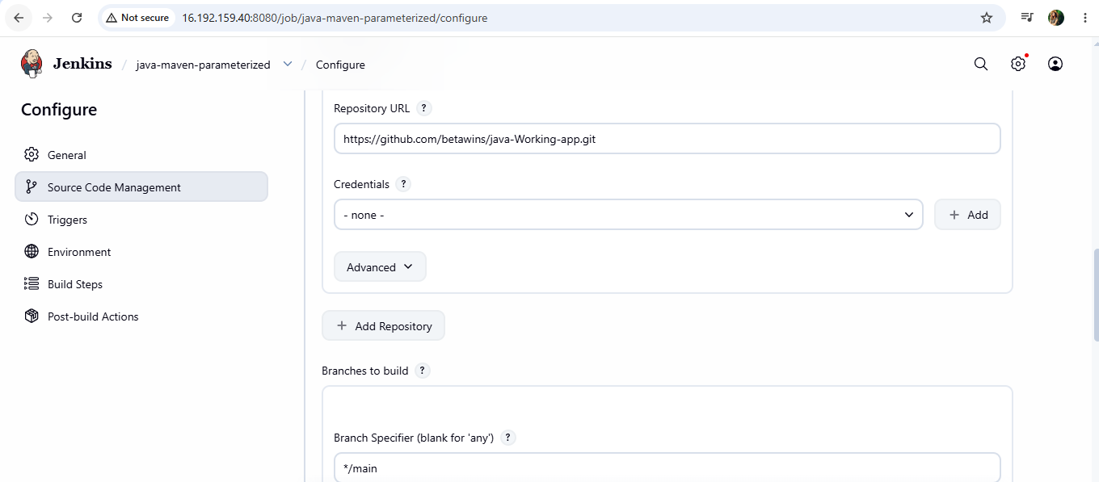

Step 4: Stage 2 — Maven Compilation
Under Build Steps, select: Execute shell
Add:
echo "Starting Maven compilation..."
mvn clean compile
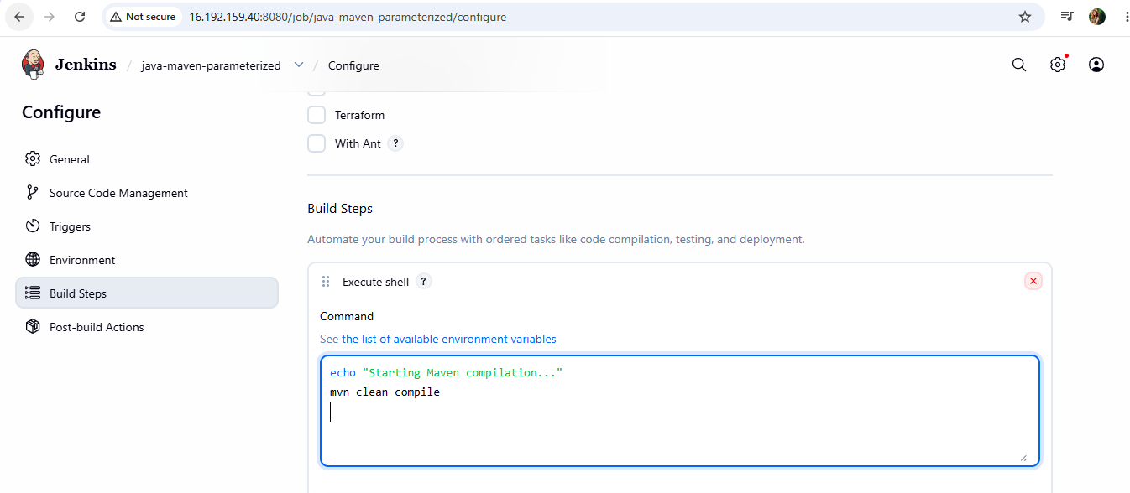

Step 5: Run the parameterized job
Click Build with Parameters instead of Build Now.
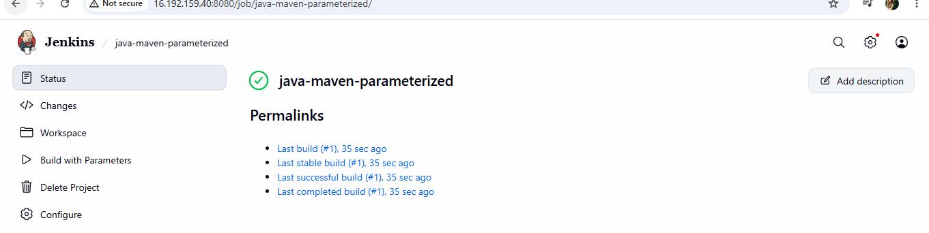
6. What are the global variables in Jenkins?
In Jenkins, global variables are predefined variables that are available throughout a Jenkins Pipeline. They are mainly provided through Jenkins' Global Variable Reference and Pipeline steps/plugins.

Common Jenkins global variables
Variable | Purpose | Example
env | Access environment variables | env.BUILD_NUMBER
params | Access build parameters | params.BRANCH_NAME
currentBuild | Access information about the current build | currentBuild.result
scm | Represents the configured Source Code Management | checkout scm
docker | Docker Pipeline functionality, when the Docker plugin is available | docker.image(...)

